NEWS RELEASE
Glaswegian artist Jasleen Kaur has first major Scottish exhibition at Tramway
- Alter Altar: Jasleen Kaur
- Preview: Thursday 30 March 2023; 7:30pm - 9:30pm
- Exhibition: Friday 31 March to Sunday 8 October 2023
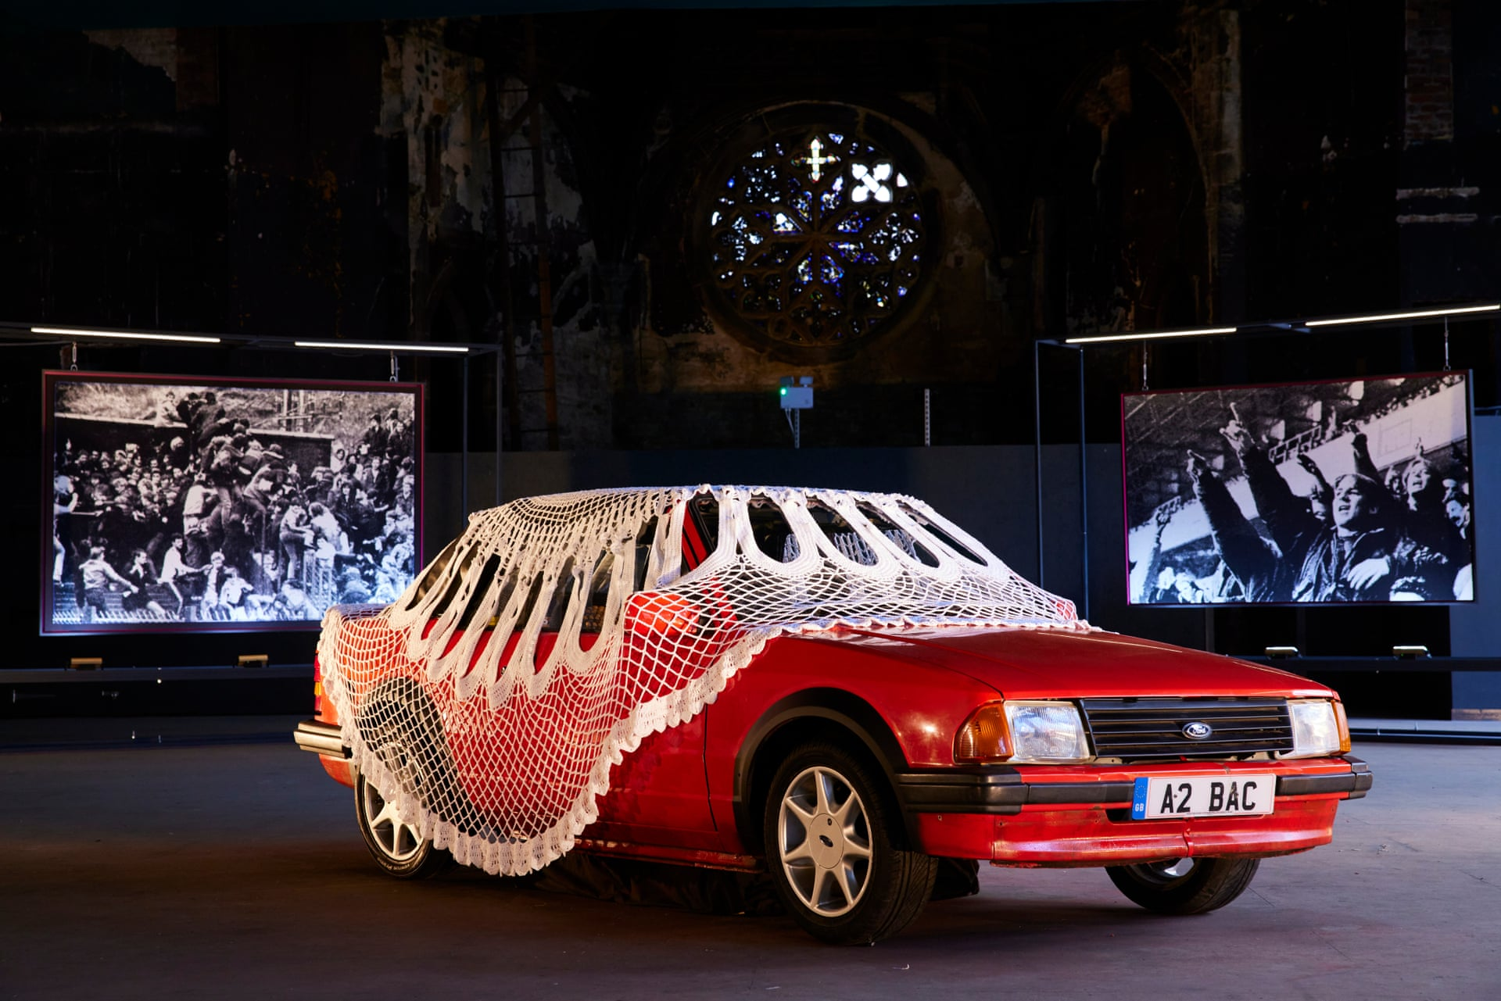
Jasleen Kaur, Sociomobile, Red Ford Mk3 Escort Cabriolet XR3i, crocheted doily and sound, British Textile Biennial 2021

Jasleen Kaur was born in 1986 in Pollokshields, not far from Tramway. The Glasgow artist’s new exhibition fills the gallery with sound, making a temporary space to bring together her work mapping and tracing local geographies in relation to the artist's personal lineages.

Through a series of installations and kinetic, musical sculptures Kaur explores ideas of sonic memory and the cultural resonances of everyday materials and objects. Axminster carpet, bottles of blessed Irn Bru, football scarves, political flyers and salvaged family photographs are re-worked to evoke new cultural readings. In Kaur’s work, the everyday finds new and alternative meaning and explores the ways in which cultures and customs are perpetuated.

An expansive sky suspended in the gallery taps into religious imagery, the heavens, angelic realms, a place of liberation. Strewn among the clouds are various objects and detritus that cling to Kaur’s personal memories - political leaflets, newspaper clippings, commodified images of saints and sinners, all remade from recollections. The words ‘LOOOOONGING’ and ‘CAN’T DO IT’ feature on a fan scarf and tracksuit and symbols and logos on clothing consider how bodies enact and perform ideologies.
Kaur has incorporated worship bells into a series of new kinetic sculptures resembling gesturing hands that point and tap. Once made from Indian rose wood, the hands are rendered by the artist in brightly coloured veneers echoing the prevalence of faux and facades in migrant aesthetics. These large-scale, musical sculptures tap automatically in syncopated rhythms, the bells holding a pulse for the space, moving to faster paced, ecstatic rhythms that echo communal chanting or call and response. They also signal and point repeatedly to images that act as symbols of cross-cultural solidarity.

Kaur explores music’s potential to reflect on existing identities whilst simultaneously constructing new ones in the process. Her work considers the impact on shared Sikh-Muslim cultural heritage following the 1947 Partition of the Indian subcontinent under British colonial rule, particularly the subsequent degradation of Sikh-Rababi musical heritage. These themes are echoed through the inclusion of colonial instruments such as the Indian Harmonium, tracing a broader narrative thread across the exhibition which explores the continuing geo-political and cultural ramifications of colonial histories and State power.
“I learned devotional singing on a harmonium from my dad, but since then, I think of my singing practice as a decolonial practice.”
Together the works create a choric structure for the exhibition which weaves together the soundtrack of Kaur’s upbringing in Pollokshields. This sonic and psychic landscape includes an immersive sound work featuring the artist’s own vocals, improvising with inherited practices from her Sikh upbringing as well as political pop, Sufi Islamic devotional music and colonial instruments re-imagined as sonic sculptures. Playing independently and in unison, the space emits a polyphony of sound and identities, reflecting the slipperiness of grasping a singular cultural identity that history often imposes.
Throughout the exhibition Kaur evokes choric formations and the ways in which community and cultural identity is performed through collective action. The space itself is a re-imagined hybrid of various places of devotional worship — the carpet, ceiling panels echoing temples, waiting rooms and makeshift contexts, whilst also creating new inclusive architectures for an imagined community.

Further information on artworks:

A major work in the exhibition features a Red Ford Mk3 Escort Cabriolet XR3i which Kaur describes as a ‘representation of my dad's first car and his migrant desires’. An enormous 4m hand-crocheted doily covers the car, linking materially to legacies of Empire, cotton, and migration from ex-colonies to British mills after the World War. Sonically the vehicle is also an institution of Kaur’s musical memory; it was one of the few places music was played and listened to as a family — Bob Marley and Nusrat Fateh Ali Khan being the political soundtrack that informed Kaur’s childhood. Short snippets play occasionally in the space, sounding as if a car is driving past you in the street; booming bass resounding from a subwoofer in the boot — a reference to Kaur’s older brothers’ handmade speakers.
Recent and upcoming commissions by Kaur include Tramway, Glasgow, as well as Wellcome Collection, Touchstones Rochdale, Glasgow Women’s Library, BALTIC Centre for Contemporary Art and Hollybush Gardens. Kaur’s work is part of the permanent collection of Arts Council, Touchstones Rochdale, Government Art Collection and Crafts Council.
Link to images
https://drive.google.com/drive/folders/1gXvyGpHay6nvMQQJnJzros43CaPPtZXj
Image credit
Flesh 'n' Blood, (detail) 2021. Courtesy of Humber Street Gallery and Jasleen Kaur. Photo credit Jules Lister
For press information contact Nicola Jeffs nj@nicolajeffs.com
Mobile: 07794 694 754

Funded by Creative Scotland

About Tramway
One of Scotland’s leading international art-spaces, the venue acts as a hub for creative excellence in contemporary visual art and performance by developing presentation and production opportunities supporting ambitious commissions and the production of new exhibitions by both Scottish and International artists.
Visit www.tramway.org

About Glasgow Life
Glasgow Life is a charity working for the benefit of the people of Glasgow. We believe everyone deserves a great Glasgow life and we find innovative ways to make this happen across the city’s diverse communities. Our programmes, experiences and events range from grassroots community activities to large-scale cultural, artistic and sporting events which present Glasgow on an international stage. Our work is designed to promote inclusion, happiness and health, and to support the city’s visitor economy in order to enhance Glasgow’s mental, physical and economic wellbeing.
Visit www.glasgowlife.org.uk

