Glasgow Life email signature instructions

Our email signature helps us introduce or reinforce who we are as an organisation. By having a single brand signature, used consistently by every colleague, we create brand recognition through every email we send.

All Glasgow Life email signatures should only carry the Glasgow Life logo – it should be kept clean of all other logos or information.

Please follow these instructions to add our email signature to your emails.

1 In Outlook, Click File at the top left-hand side

2 Select ‘Options’ from the menu that has appeared

3 Select ‘Mail’ from the menu

4 Click the ‘Signatures’ box

5 Click on ‘New’ to set up a new signature

6 Step 1

Copy and paste the text supplied below, changing the details to reflect your own. Please ensure you use size 11 Calibri (Body) font in the colour black. The space between name/job title and contact details are deliberate to allow you to use it as your sign off.

Jane Doe
Office Manager

Glasgow Life | Commonwealth House | 38 Albion Street | Glasgow | G1 1LH
Email: jane.doe@glasgowlife.org.uk | www.glasgowlife.org.uk
T: XXXX XXX XXXX | M: XXXXXXXXXXX

Step 2

Copy and paste the jpeg below directly from this document under this text. Please keep it at the same size at the one below. It’s important you use this jpeg as it includes alternative text to describe the image. This text helps screen-reading tools describe images to visually impaired readers.

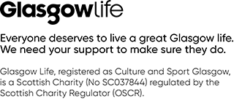

Step 3

Please add a link to our website by clicking on the Glasgow Life logo image you’ve just pasted and then clicking on this icon at the top right hand side.

Paste the following URL into the address bar: https://www.glasgowlife.org.uk/support-us

This link will not be visilble, however it will make the image clickable and take users through to the website. This is the only link that should be included in our signature.

7 Click Save

Our corporate signature should look like the example below:
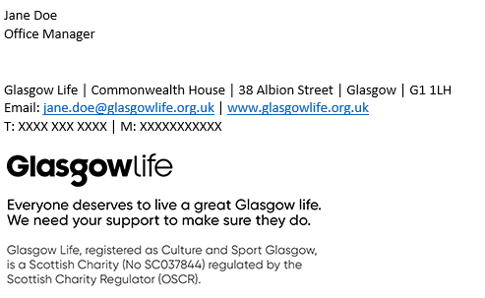

Email signatures are useful for contact details in an email chain, so please set your Glasgow Life email signature to be on automatic for all new emails.

When it comes to replies and forwards, we recommend inserting your email signature when you think it is required (e.g if you have just been in a thread, or are forwarding something externally). Please only use your set Glasgow Life email signature and do not create a different version.

Please also ensure you use size 11 Calibri (Body) font within all replies and new emails. You can change your default font by following the instructions above to step 3 and then clicking on ‘Stationary and Fonts’.

Optional additions

There may be some very specific language required to be included in email signatures depending on your role. An example of this is below:

Any advice contained in this email is strictly privileged and confidential and is intended for use by the recipient only.

You may wish to add information on your working pattern. If so, please use the example below as a template:

I work Monday – Wednesday and will not respond to emails outwith those days.

If either of these are needed, please paste the words at the very bottom of the signature (after you insert the jpeg).

